****Practical 3-Visual Solution****

****Video Processing And Motion Detection****

**Disclaimer: Please be aware that your results may be slightly different depending on your parameters, etc.. This is just for visual help.**

****TASK 1: Reading Video Files****

**Step 5**:

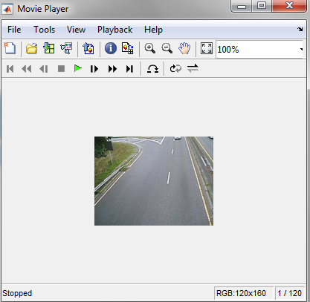

**Step 7**:



**Step 9**:



****TASK 2: Motion Detection Using Background Subtraction****

**Step 4**:



**Step 10**: See attached video 'resultTraffic.avi'

****TASK 3: Background Update****



****TASK 4: PostProcessing****

See attached video 'Task3.mp4'